20XC17 – C PROGARMMING LAB CA1 TEST

S VARUN 21PC26

19/11/2021

1. PROGRAM

#include <stdio.h>

int main()

{

int Number_1, Number_2;

int Sum_Of_Number1_Divisors = 0, Sum_Of_Number2_Divisors = 0 ;

printf("ENTER THE TWO NUMBERS : ");

scanf("%d %d", &Number_1, &Number_2);

for(int i=1 ; i<=Number_1 ; i++)

{

if(Number_1 % i == 0)

Sum_Of_Number1_Divisors = Sum_Of_Number1_Divisors + i;

}

for(int i=1 ; i<=Number_2 ; i++)

{

if(Number_2 % i == 0)

Sum_Of_Number2_Divisors = Sum_Of_Number2_Divisors + i;

}

if((Sum_Of_Number1_Divisors/Number_1) == (Sum_Of_Number2_Divisors/Number_2))

{

printf("%d and %d are friendly numbers", Number_1, Number_2);

}

else

{

printf("%d and %d are not friendly numbers", Number_1, Number_2);

}

return 0;

}

OUTPUT:

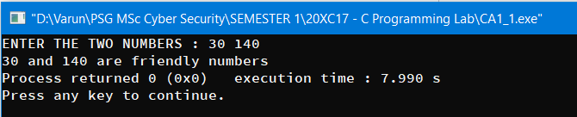

1. PROGRAM

#include<stdio.h>

void main()

{

int No_Of_Users, Salary, i;

float Tax;

char Marital_Status;

printf("Enter Number of Users : ");

scanf("%d", &No_Of_Users);

for(i=1 ; i<=No_Of_Users ; i++)

{

printf("Enter Martial Status S / M : ");

scanf(" %c", &Marital_Status);

printf("Enter Gross Salary : ");

scanf("%d", &Salary);

if(Marital_Status == 'S')

Salary = Salary - 4000;

else

Salary = Salary - 7000;

if(Salary >= 1000 && Salary <= 15000)

{

Tax = Salary*0.15;

printf("Federal Tax : %f \n\n", Tax);

}

else if(Salary >= 15001 && Salary <= 40000)

{

Tax = (Salary*0.25 + 2250);

printf("Federal Tax : %f \n\n", Tax);

}

else if(Salary > 40000)

{

Tax = (Salary*0.35 + 8460);

printf("Federal Tax : %f \n\n", Tax);

}

}

}

OUTPUT :

